1. Copy CSS from bootstrap

2. <link rel="stylesheet" href="style.css">

3. Create a style.css file

4. First create header from <header> tag

(This is required as we want whole screen color. Div container does not cover the whole screen)

5. Create **bg-color** style in style.css to color the background of the header.

Add the said class to the header and navbar tag

6. <nav class="navbar navbar-expand-lg navbar-light bg-light">

The default bg-light must be removed as we would like to color the header with our own color

7. We have to fluid the image (so the full image fits on the header) by adding a bootstrap default class to the img tag:

class="img-fluid">

i.e.

<a class="navbar-brand" href="#">

                <img src="images/icon/Logo.png" alt="" class="img-fluid">

The image size is too large. We have to resize it by adding following style:

.navbar-brand img{

    width: 200px;

}

(So that the **img** attribute (default attribute of html) of bootstrap class **navbar-brand** will be resized at 200px )

8. Edit the menu item as per design from <li> tag

9. Edit the <ul> tag by adding class property

ml-auto font-weight-bold

ml-auto: right align

font-weight-bold: bold the menu color

But we want menu in black color for the following class:

navbar-nav

.navbar-nav{

    color: black;

    padding: 8px 20px;

}

Eventually we have edited <ul> tag as follow:

 <ul class="navbar-nav ml-auto font-weight-bold">

10. We have to style the **sign in** button

signin-btn text-white

.signin-btn{

    background-color: #21B573;

    color: white;

    border: none;

    border-radius: 25px;

    padding: 8px 25px;

}

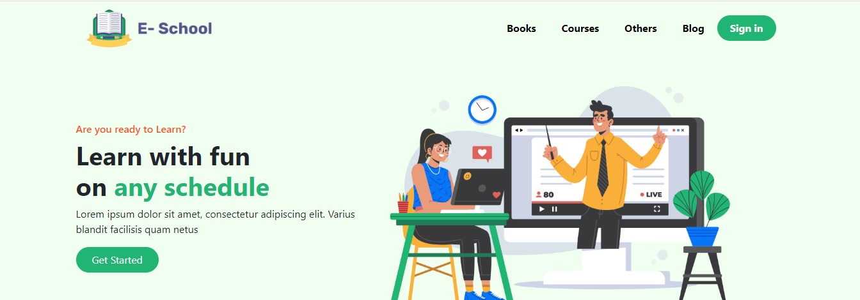

11. Now we want to add the below portion of the header of the above picture.

12. We need a <section> before <div class=”container”> to color the whole background of the screen.

<section class="bg-color">

    <div class="container">

    <div class="row">

        <div class="col-md-5">

        </div>

        <div class="col-md-7">

        </div>

    </div>

</div>

</section>

13. Add the photo between col-md-7 div.

<img src="images/photos/Illustration.png" alt="" class="src">

To fit the image properly use **img-fluid** class:

class="img-fluid"

14. Now we have to complete the left column job:

<h6>Are you ready to Learn?</h6>

            <h1 class="font-weight-bolder">Learn with fun <br>on <span class="text-green">any schedule</span>

            </h1>

            <p>Lorem ipsum dolor sit amet, consectetur adipiscing elit. Varius blandit facilisis quam netus </p>

            <button class="green-btn">Get Started</button>

We have to style <h6> as follow:

.bg-color .row h6{

    color: #FD511A;

}

We will use **font-weight-bolder** to style the following line. Note: font-weight-bolder will style bolder that **font-weight-bold**

# 15. To enter a new line for on any schedule we will use <br>

To color **any schedule**, We will use another class **“text-green”**

<span class="text-green">any schedule</span>

.text-green{

    color: #21B573;

}

16. Now we will style the **Get Started** button:

<button class="green-btn">Get Started</button>

.green-btn{

    background-color: #21B573;

    color: white;

    border: none;

    border-radius: 25px;

    padding: 8px 25px;

}

17. Now we have to center the items of the row:

<div class="row align-items-center py-5">

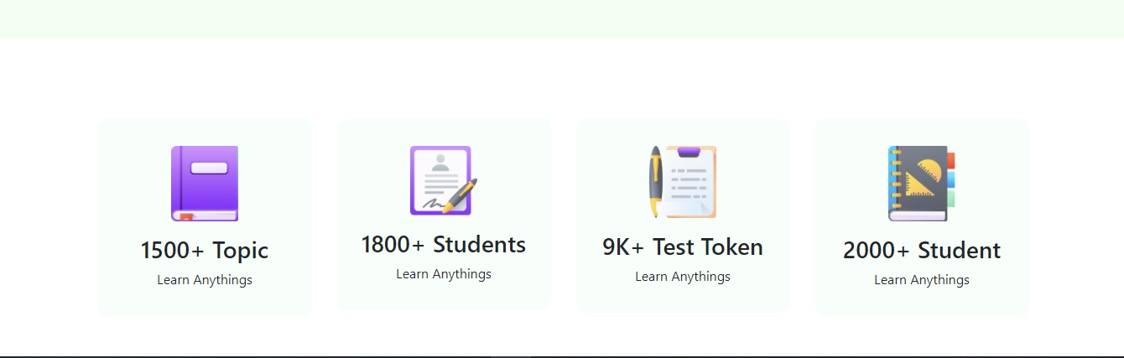

18. We have to place 4 icons in a same row by using

<div class="col-md-3">

19. We have to define the size of the **icons-box** in the div container with a padding i.e. **p-3**:

.icons-box{

    background-color: #F8FFFB;

    border: none;

    border-radius: 10px;

}

And **p-3** allows same padding four direction.

We have define a new style i.e. **height-img** to allocate same size pic for all pics.

.height-img{

    height: 90px;

}

We have used a default **mt-3** style class (margin top) to allocate some spaces on top of the image.

We have used a default **pt-3** style class (padding top) to allocate some spaces on top of the text.

<div class="col-md-3">

            <div class="icons-box p-3">

                <img class="height-img mt-3" src="images/icon/book.png" alt="">

                <h3 class="pt-3">1500+ Topic</h3>

                <p>Learn Anythings</p>

            </div>

        </div>

m - sets margin

p - sets padding

t - sets margin-top or padding-top

b - sets margin-bottom or padding-bottom

l - sets margin-left or padding-left

r - sets margin-right or padding-right

x - sets both padding-left and padding-right or margin-left and margin-right

y - sets both padding-top and padding-bottom or margin-top and margin-bottom

blank - sets a margin or padding on all 4 sides of the element

We have align the row center with proper padding top and align section with proper margin

<section class="container mt-5 mb-5">

    <div class="row text-center pt-5">

20.

<https://getbootstrap.com/docs/4.0/components/card/>

Card decks

To allowing padding 3 from the card-deck:

<div class="card p-3">

Add a green button (the **green-btn** style has been discussed previously):

<button class="green-btn">Buy Course</button>

 <div class="card-deck mt-5">

<div class="card p-3">

        <img src="images/photos/Morder psyc.png" class="card-img-top" alt="...">

        <div class="card-body">

            <h5 class="card-title">Data Structures and Algorithms</h5>

            <p class="card-text">Javin Paul</p>

            <button class="green-btn">Buy Course</button>

        </div>

        <div class="card-footer d-flex">

            <div class="d-flex">

                <img src="images/icon/calendar.png" alt="">

                <h6 class="mt-1 ml-1">Start 20 June,2021</h6>

            </div>

            <div class="d-flex ml-auto">

                <img src="images/icon/people.png" alt="">

                <h6 class="mt-1 ml-1">60 seats</h6>

            </div>

        </div>

    </div>

</div>

Style:

/* online courses article style */

.card{

    border: none;

    border-radius: 15px;

    box-shadow: 2px 10px 15px 5px lightgray;

}

.card-footer{

    border: none;

    background-color: white;

}

.card-footer img{

    width: 25px;

    height: 25px;

}

d-flex:

in footer, we have used two d-flex

1. Calendar icon with date
2. People icon with number of people

Actually **d-flex** flexible items in a row (by default left to right).

<div class="d-flex">

                <img src="images/icon/calendar.png" alt="">

                <h6 class="mt-1 ml-1">Start 20 June,2021</h6>

            </div>

It flexibles No.1

<div class="d-flex ml-auto">

                <img src="images/ICON/people.png" alt="">

                <h6 class="mt-1 ml-1">60 seats</h6>

            </div>

It flexibles No.2

And eventually, we have two flexible the abovementioned two:

<div class="card-footer d-flex">

mt-1 ml-1

just allow Margin Top and Margin Left for 1.